***Name:Areeb Bhatti***

***Class:IT-3A***

***ID:BIT-23F-027***

***TASK 1***

1. .Write a Python function that takes a number as input and returns the sum of its digits

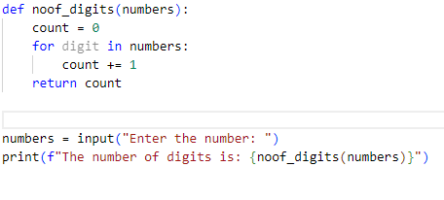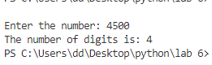

***TASK 2***

1. Write a Python function that takes a sentence as input and returns the number of words in it.

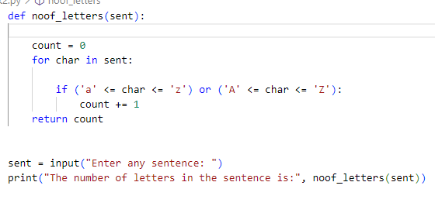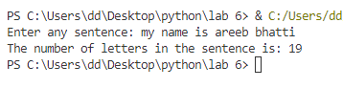

***TASK 3***

1. Write a Python function that takes an integer and returns whether the number is even or odd.

